

Functional Safety Concept Lane Assistance

**Document Version: [Version]**

**Template Version 1.0, Released on 2017-06-21**



# Document history

|  |  |  |  |
| --- | --- | --- | --- |
| Date | Version | Editor | Description |
| 23/05/2018 | 1.0 | Krishna | 1st version of Functional Safety Concept |
| 25/05/2018 | 2.0 | Krishna | 2nd version of Functional Safety Concept |
|  |  |  |  |
|  |  |  |  |
|  |  |  |  |

# Table of Contents

[Document history](#_1t3h5sf)

[Table of Contents](#_ktt3lgighckp)

[Purpose of the Functional Safety Concept](#_fulgh8sf1ocg)

[Inputs to the Functional Safety Analysis](#_757cx6xm46zb)

[Safety goals from the Hazard Analysis and Risk Assessment](#_pi1c1upmo8jt)

[Preliminary Architecture](#_s0p6ihti6jgk)

[Description of architecture elements](#_cqb49updinx4)

[Functional Safety Concept](#_mx8us8onanqo)

[Functional Safety Analysis](#_mtn6qbhgsr36)

[Functional Safety Requirements](#_frlc9y84ede8)

[Refinement of the System Architecture](#_74udkdvf7nod)

[Allocation of Functional Safety Requirements to Architecture Elements](#_g2lqf7kmbspk)

[Warning and Degradation Concept](#_4w6r8buy4lrp)

# 

# Purpose of the Functional Safety Concept

The main purpose of the Functional Safety Concept is to refine the Safety Goals, identify new requirements and allocate these requirements. Using the concept from Hazard Analysis and Risk Assessment, it tries to identify the requirements to lower the risk levels. It evaluates the risk of the hazardous situation so that we know how much we need to lower the risk. The functional safety concepts lead to Technical Safety Concept.

# Inputs to the Functional Safety Concept

## Safety goals from the Hazard Analysis and Risk Assessment

|  |  |
| --- | --- |
| **ID** | **Safety Goal** |
| Safety\_Goal\_01 | The oscillating steering torque from the Lane Departure Warning function shall be limited. |
| Safety\_Goal\_02 | The Lane Keeping Assistance function shall be time limited, and additional steering torque shall end after a given time interval so the driver cannot misuse the system for autonomous driving. |

## Preliminary Architecture

### **D:\download\safety_project_files\safety_project_files\diagrams\graphic_asset_2.jpg**

### Description of architecture elements

|  |  |
| --- | --- |
| **Element** | **Description** |
| Camera Sensor | It takes visual feedback for the lane detection. It captures images and feeds the images to the Camera Sensor ECU |
| Camera Sensor ECU | It analyses the camera images using computer vision or some other techniques. It determines whether the car is going out of the lane. It sends this information to the Car Display system as well as power steering ECU |
| Car Display | It displays whether the lane keeping and departure assistance system is on/off. So, basically it is a visual feedback for the driver. |
| Car Display ECU | Generates warning signals depending upon the input from the camera sensor ECU and Electronic Power Steering ECU to pass it to the Car Display. |
| Driver Steering Torque Sensor | It measures the amount of torque being applied on the steering wheel and sends it to the Electronic Power Steering ECU |
| Electronic Power Steering ECU | Processes inputs from the camera sensor ECU, driving steering torque sensor and generates appropriate Lane Assistance functionality. Sends the output to the motor. |
| Motor | It is the component which actually applies the torque to rotate the steering wheel |

# Functional Safety Concept

The functional safety concept consists of:

* Functional safety analysis
* Functional safety requirements
* Functional safety architecture
* Warning and degradation concept

## Functional Safety Analysis

|  |  |  |  |
| --- | --- | --- | --- |
| **Malfunction ID** | **Main Function of the Item Related to Safety Goal Violations** | **Guidewords (NO, WRONG, EARLY, LATE, MORE, LESS)** | **Resulting Malfunction** |
| Malfunction\_01 | Lane Departure Warning (LDW) function shall apply an oscillating steering torque to provide the driver a haptic feedback | MORE | The lane departure warning function applies an oscillating torque with very high torque amplitude |
| Malfunction\_02 | Lane Departure Warning (LDW) function shall apply an oscillating steering torque to provide the driver a haptic feedback | MORE | The lane departure warning function applies an oscillating torque with very high torque frequency |
| Malfunction\_03 | Lane Keeping Assistance (LKA) function shall apply the steering torque when active in order to stay in ego lane | NO | The lane keeping assistance function is not limited in time duration which leads to misuse as an autonomous driving function. |

## Functional Safety Requirements

Lane Departure Warning (LDW) Requirements:

|  |  |  |  |  |
| --- | --- | --- | --- | --- |
| **ID** | **Functional Safety Requirement** | **ASIL** | **Fault Tolerant Time Interval** | **Safe State** |
| Functional  Safety  Requirement  01-01 | The lane keeping item shall ensure that the lane departure oscillating torque amplitude is below Max\_Torque\_Amplitude | C | 50 mS | The LDW torque amplitude should be below Max\_Torque\_Amplitude and if fault occurs its value should be set to zero |
| Functional  Safety  Requirement  01-02 | The lane keeping item shall ensure that the lane departure oscillati9ng torque frequency ids below Max\_Torque\_Frequency | C | 50 mS | The LDW torque frequency should be below Max\_Torque\_Frequency and if fault occurs its value should be set to zero |

Lane Departure Warning (LDW) Verification and Validation Acceptance Criteria:

|  |  |  |
| --- | --- | --- |
| **ID** | **Validation Acceptance**  **Criteria and Method** | **Verification Acceptance**  **Criteria and Method** |
| Functional  Safety  Requirement  01-01 | For whatever value we end up choosing for the max torque amplitude, we need to **validate** that we chose a reasonable value. We would need to test how drivers react to different torque amplitudes to prove that we chose an appropriate value. | When the torque amplitude crosses the limit, the lane assistance output is set to zero within the 50 mS fault tolerant time interval. |
| Functional  Safety  Requirement  01-02 | For whatever value we end up choosing for the max torque frequency, we need to **validate** that we chose a reasonable value. We would need to test how drivers react to different torque frequency, to prove that we chose an appropriate value. | When the torque frquency crosses the limit, the lane assistance output is set to zero within the 50 mS fault tolerant time interval. |

Lane Keeping Assistance (LKA) Requirements:

|  |  |  |  |  |
| --- | --- | --- | --- | --- |
| **ID** | **Functional Safety Requirement** | **ASIL** | **Fault Tolerant Time Interval** | **Safe State** |
| Functional  Safety  Requirement  02-01 | The electronic power steering ECU shall ensure that the lane keeping assistance torque is applied for only Max\_Duration | B | 500 mS | Lane Keeping Assistance System torque should be set to zero. |

Lane Keeping Assistance (LKA) Verification and Validation Acceptance Criteria:

|  |  |  |
| --- | --- | --- |
| **ID** | **Validation Acceptance**  **Criteria and Method** | **Verification Acceptance**  **Criteria and Method** |
| Functional  Safety  Requirement  02-01 | Test and validate that the max\_duration chosen really did dissuade drivers from taking their hands off the wheel. | The system turns off if the lane keeping assistance ever exceeded max\_duration |

## Refinement of the System Architecture

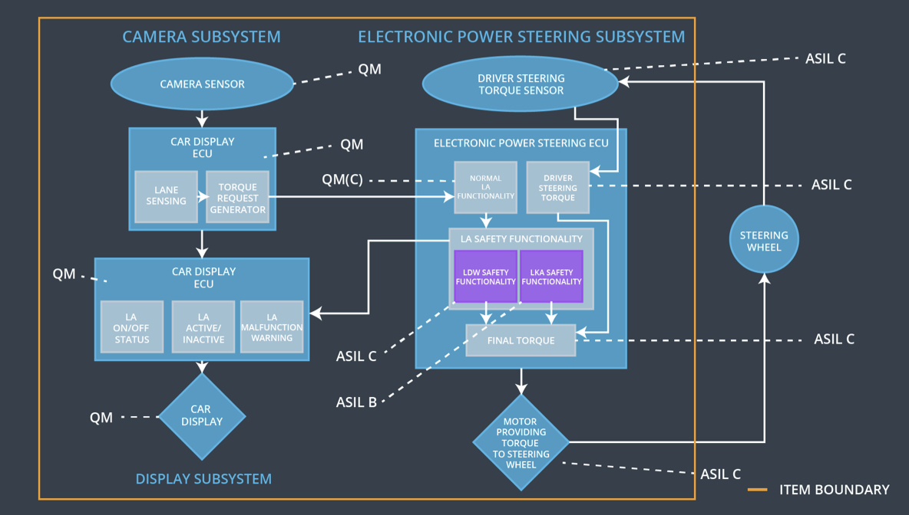

## Allocation of Functional Safety Requirements to Architecture Elements

|  |  |  |  |  |
| --- | --- | --- | --- | --- |
| **ID** | **Functional Safety Requirement** | **Electronic Power Steering ECU** | **Camera ECU** | **Car Display ECU** |
| Functional  Safety  Requirement  01-01 | The lane keeping item shall ensure that the lane departure oscillating torque amplitude is below Max\_Torque\_Amplitude | **Yes** | **No** | **No** |
| Functional  Safety  Requirement  01-02 | The lane keeping item shall ensure that the lane departure oscillati9ng torque frequency ids below Max\_Torque\_Frequency | **Yes** | **No** | **No** |
| Functional  Safety  Requirement  02-01 | The electronic power steering ECU shall ensure that the lane keeping assistance torque is applied for only Max\_Duration | **Yes** | **No** | **No** |

## Warning and Degradation Concept

|  |  |  |  |  |
| --- | --- | --- | --- | --- |
| **ID** | **Degradation Mode** | **Trigger for Degradation Mode** | **Safe State invoked?** | **Driver Warning** |
| WDC-01 | Turn off the functionality | The malfunction of steering wheel vibrating too high or with more frequency | Yes | Display will show the warning light on |
| WDC-02 | Turn off the functionality | The malfunction of lane keeping assistance applied for long duration | Yes | Display will show the warning on |